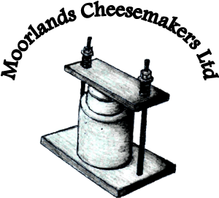
Moorlands Cheesemakers Ltd.
Foundry House
The Street
West Raynham
North Norfolk
NR21 7EZ

01328838478 or 07745170390

September 2023
BUCW2538 Waxed Cheesewrap
Application: Wrapper suitable for direct contact with a range of cheeses, raw meat, fish and other high moisture items. Conforming to the following specifications and is produced in accordance with BRC/IoP protocols.
Substrate: Machine-glazed opacified bleached Kraft. FDA regulations (21 CFR Part 176.170)
Weight: 44.0+/-2.2gsm (nominal)
Make-up: Two sided waxed coated with 13.0gsm +/2.0gsm, fully refined paraffin wax, conforming to F & DA approval (CFR21.175.105 and CFR21.176.170, with respect to contact aqueous and fatty foodstuffs), total substance weight 60gsm+/2.0gsm.
Finishing: Guillotined and packed as per customer requirements.
Notes: This product is biodegradable and compostable. The base paper is produced using 100% virgin pulp from sustainably, managed forests. Recycling this product can also be done where facilities exist.

